Task 1

Hyaluronic acid

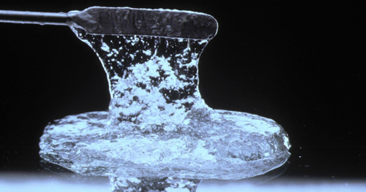

10. 05. 2022.
Hradec Králové
Czechia

Preface
Our body is a masterpiece. And not only our own, but of all the organisms. Nature is a gallery inhabited by an examples optimized by the creativity of the natural selection. The sculptor is therefore an evolution. It uses the available chemistry and physics to invent the optimized assemblies with a features which are hard to beat with the cutting edge technologies.
Molecular “gems” are not only constituent parts of our cells but are secreted as extracellular matrix to provide the multicellular organisms with striking mechanical properties. Collagen and elastin are well known examples of the proteins providing the tissues with the strength and elasticity. The same importance belongs to the molecules similar to carbohydrates, which are highly hydrated and in many modified variants enabling our body to behave in many aspects “smart” and cost effectively.
In our task you experience one of the most important extracellular matrix molecules – the hyaluronic acid –from different points of view to uncover it´s peculiar properties. It should be mentioned that hyaluronic acid is getting more and more interest in biomedicine as biochemical, which could be used to treat several pathologies, to assist in vitro cultivated tissues for regeneration medicine or even could be used for beautification or anti-aging interventions. To isolate and properly characterize the hyaluronic acid, chemical and physical methodologies need to be applied. Our task is using some of them with intention to blur the borderlines between the disciplines of the natural science. As already mentioned, biology, chemistry and physics joined together to become an evolutionary “sculptor” .

Part A
Introduction
Skin – many layers, different composition
Mammalian skin consists of several layers and fulfills various roles. It covers and protects the body, allows communication with external environment, maintains homeostasis of the body, etc. The skin of a particular species is adapted to its lifestyle and habitat. We will look closer at the skin of a house mouse (Mus musculus, Fig. A1) and naked mole-rat (Heterocephalus glaber, Fig. A2). Both are rodents (Rodentia), and their bodies are of similar size. However, their lifestyles differ markedly.
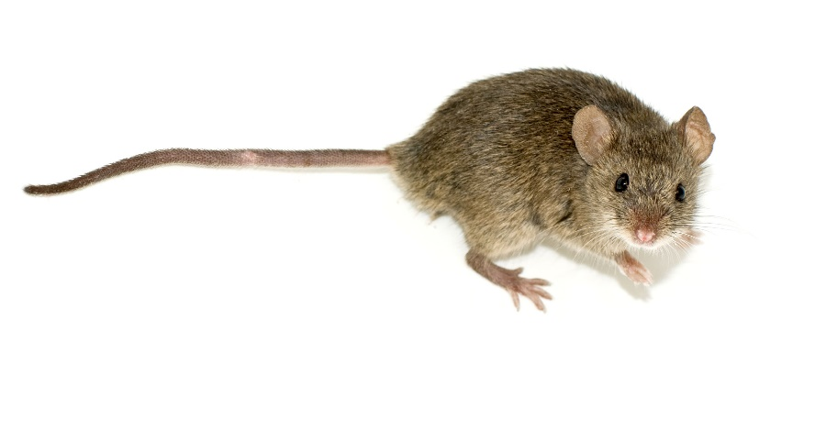
Fig. A1 House mouse.

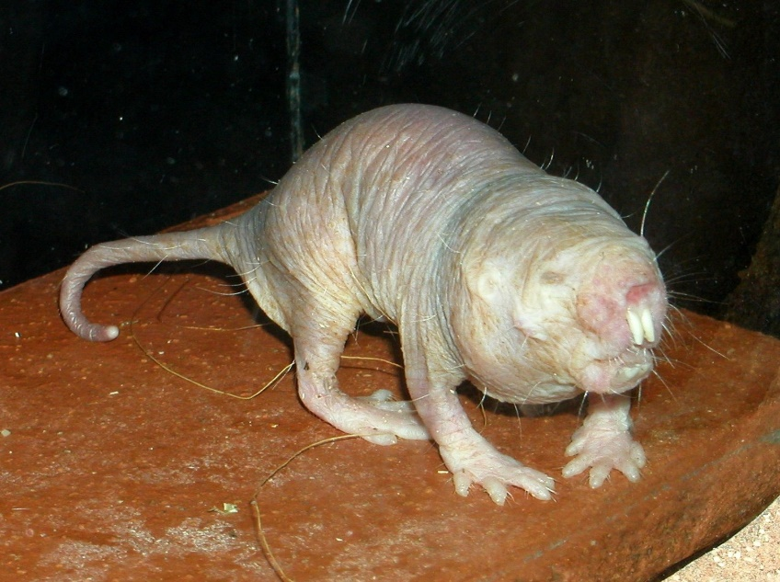
Fig. A2 Naked mole-rat.

Material and chemicals for experiments in Task A1 and Task A2
Each team
- Microscope
- Distilled water in a wash bottle
- Plastic Falcon tube labeled H – with 8 mL hematoxylin dye
- Plastic Falcon tube labeled E – with 8 mL eosin dye
- Beaker as a rack for the Falcon tubes
- Eppendorf tube labeled M – with 1 mL mounting medium Rotihistokitt
- 4 plastic Pasteur pipettes
- 2 beakers for waste – one for liquid waste, second for solid waste
- Forceps enabling better manipulation with glass slides
- Petri dish containing 4 glass slides labeled A, B, C, D and two long glass coverslips
- Plastic box with two built-in glass tubes
- Paper towels or tissues

Shared in each laboratory
- Gloves, different sizes (pick your size)
- Wall clock
- Glass jars with lids containing:
- Rotihistol (labeled Roti)
- 100% ethanol (labeled EtOH 100)
- 96% ethanol (labeled EtOH 96)
- 80% ethanol (labeled EtOH 80)

Task A1 (20.5 points)
For the first task, you will use two glass slides: slide A and slide B. There are several paraffin skin sections attached onto each slide. One slide contains skin sections from mouse, the other sections from naked mole-rat. Both skins were fixed, embedded in paraffin, and thin sections were cut on microtome.
Perform the same histology staining on both slides in parallel by following the protocol provided below. Take extra care not to touch the skin sections; they can be rubbed off or damaged very easily!
Experimental Procedure
- Deparaffinize the sections in Rotihistol for 5 min. Insert the slide into the accordingly labeled glass jar. (There are grooves in the glass wall to hold the slides.) Insert the slides into the jar carefully. Neighboring slides must not touch each other.
- Transfer the slides to 100% ethanol, incubate for 4 min.
- Transfer the slides to 96% ethanol, let hydrate there for 4 min.
- Transfer the slides to 80% ethanol, let hydrate there for 4 min.
- Bring the slides back to your bench and place them on the glass tubes built in the plastic box, skin sections facing upward as in the diagram below. Rinse the slides with lots of distilled water at least 5 times. The water should flow gently to avoid washing away the sections. Continue with steps 6 – 9 also in the plastic box with the built in glass tubes.
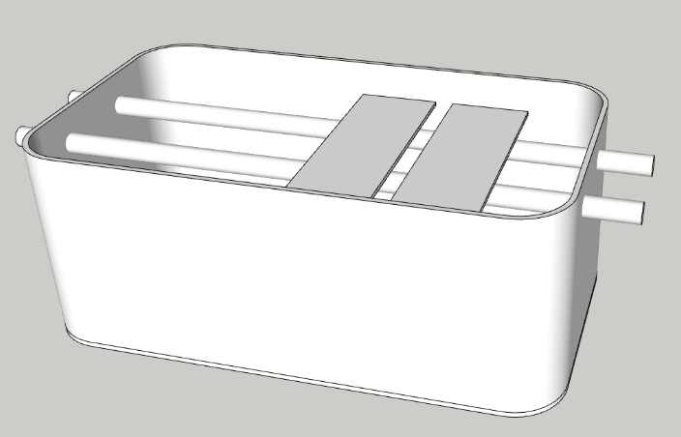
- Overlay all sections with approx. 3 mL of hematoxylin on each slide, incubate in hematoxylin for 3 min.
- Carefully and gently rinse the slides with distilled water until you wash away the excess dye.
- Overlay all sections with approx. 3 mL of eosin on each slide, incubate in eosin for 3 min.
- Carefully and gently rinse the slides with distilled water until you wash away any excess dye.
- Insert the slides into the glass jar with 80% ethanol, let dehydrate for 3 min.
- Transfer them to 96% ethanol, dehydrate further for 3 min.
- Transfer the slides to 100% ethanol, incubate for 4 min.
- Incubate in Rotihistol for 5 min.
- Bring the slides back to your bench. Place them on a paper towel and carefully cover the area with skin sections by the mounting medium (Rotihistokitt). Do NOT touch the sections. Cover with long coverslips, avoid bubbles. Wait several minutes before you put the slides under the microscope.
- Observe first with 10x objective, later with 40x objective. Be careful, the mounting medium is still not solid!
Draw a representative picture of your sections from slides A and B. Label them using terms from Table A1 below. Use as many terms as you can for these samples. However, you don’t have to use all of them, and you should only draw and label structures you are actually able to see. Observe the section carefully and decide which slide contains mouse / mole-rat skin sections.
A | arrector pili (hair erector) muscle
B | basal membrane
C | blood vessel
D | cell wall
E | chondrocyte
F | connective tissue
G | red blood cell
H | dermis
I | epidermis
J | epithelium
K | glial cell
L | hair follicle
M | microvilli
N | striated muscle
O | ribosomes
P | sebaceous gland
Q | smooth muscle cells
R | vacuole
Table A1

Question A1.1 Draw a representative section from Slide A in box 1.1 in the Answer sheet. Label with letters from the Table A1. (8 points)
Question A1.2 Draw a representative section from Slide B in box 1.2 in the Answer sheet. Label with letters from the Table A1. (8 points)
Question A1.3 Enter the correct letter (A or B) of your slides to the corresponding animal from which the skin sections were prepared into the proper box in the Answer sheet. (1 point)
Question A1.4 The outermost part of skin is called epidermis. In at least one of the samples, you may be able to distinguish its layers. The table A2 contains simplified descriptions of these layers. Label them with corresponding numbers correctly in one of your drawings from Question A1.1 or A1.2. (2 points)

1 | Stratum granulosum | Cytoplasm of cells in this layer is filled with dense masses of filaggrin and other proteins associated with keratin tonofibrils, linking them into large cytoplasmic structures. The cells also contain small structures with many lamellae containing various lipids and glycolipids. The lamellar granules undergo exocytosis, producing a lipid-rich, impermeable layer around the cells in this layer.
2 | Stratum basale | Characterized by intense mitotic activity. Contains most of the progenitor cells for all the epidermal layers.
3 | Stratum corneum | Cells of this layer continuously shed off. The cells contain only amorphous, fibrillar proteins. Their plasma membranes are surrounded by a lipid-rich layer.
4 | Stratum spinosum | Cells that very actively synthetize keratins in the cytoplasm. The keratin filaments assemble into bundles called tonofibrils, which hold layers together by maintaining cell–cell contact. During histological processing, the cells usually shrink slightly, leading to a fuzzy appearance.
Table A2

Question A1.5 Observe which parts of the sample are stained by hematoxylin most intensely. Take into consideration that hematoxylin is a basic dye, which means that it stains anionic cell components. Which biomolecule is most likely the target of hematoxylin staining? Indicate the corresponding molecule by a tick (√) in table 1.4 in the Answer sheet (select 1 answer). (1.5 point)
cellulose
water
DNA
transmembrane proteins
phospholipids
simple sugars (oligosaccharides)

THE SLIDES A AND B MUST STAY ON YOUR BENCH. THEY WILL BE COLLECTED AND EVALUATED!

Task A2 (13 points)
Besides cells, skin also contains extracellular space filled with so called extracellular matrix (ECM). ECM consists of different molecules – proteins, water, ions, and polysaccharides. One such component is hyaluronic acid (hylauronan, HA). Naked mole-rat is known to produce very large HA molecules (high molecular weight of 6–10 MDa).
HA can be visualized in the skin sections by using labelled HA-binding protein. This protein sticks to the HA and stains the HA-rich region brown. On the other hand, the HA molecules can be degraded – both in skin in vivo as well as in the skin sections by enzymes called hyaluronidases.
In Task 2 you will examine slide C and slide D. Again, there are skin sections from mouse and naked mole-rat on those slides (not necessarily in the same order as in Task 1). Both slides were divided into two sections (labeled 1 and 2). One part of each slide was treated with hyaluronidase whereas the other part was mock treated and serves as control.
The slides were already stained for you with HA-binding peptide. In order to facilitate skin layer recognition, the sections were simultaneously stained with hematoxylin.
Observe all four slide sections (C1, C2, D1, D2) under the microscope. Focus on similarities and differences between the sections.

Question A2.1 Draw all four sections into corresponding parts of the box 2.1 in the Answer sheet. Your picture doesn´t need to be as detailed as in Task 1; try to capture the main differences between the sections. Indicate the HA-rich layer with prominent brown signal by an arrow. Do so in those sections where its clearly present by an arrow and label it correctly with name of the layer. (8 points)
Question A2.2 Analyze sections C1, C2, D1, D2 and decide which part was treated with hyaluronidase and which was only mock treated. Also asses the animal origin of each section. Write the code of the section (C1, C2, D1, D2) into the corresponding field in the Answer sheet. (2 points)

Question A2.3 Where do the extracellular matrix components come from? Choose the correct statement(s) regarding the origin of the protein and polysaccharide molecules found in the matrix and label by a tick (√) in the Answer sheet. (1 point)
They are directly extracted from the surrounding environment. The animal incorporates selected molecules into both superficial and deeper layers of skin and keeps them deposited there for days or longer.
They are largely synthetized by skin microbiome (mainly bacteria). Animals with different microbiome display different composition of extracellular matrix.
They are synthetized solely by liver cells. Blood and lymph transport them to the skin.
They are synthetized by cells directly in the tissue. Some molecules are made inside the cells and subsequently exported by exocytosis; others are synthetized by transmembrane enzymes.

Question A2.4 What is the role of HA in skin and other tissues? Indicate the correct answer(s) by a tick (√) in the Answer sheet. (2 point)
It maintains sufficient hydratation of the tissue.
It can serve as lubricant, e.g., in joints.
It has a large space-filling capacity.
It regulates migration of cells.

Task A3 (20 points, no experimental work needed)
Question A3.1 One of epidermal cell types are melanocytes found mostly in the stratum basale. Their main function is the production of pigments called melanins inside membrane-bound organelles called melanosomes. Melanosomes are transported to the periphery of the cell and into cytoplasmic extensions along microtubules. What type of molecular motors would you expect to be responsible for this transport? Write your answer in the Answer sheet. (1 point)
- Kinesins
- Dyneins
- Myosins

Tips of the cytoplasmic extensions break off and are phagocytosed by surrounding keratinocytes. Inside these cells, melanosomes form protective supranuclear caps, protecting DNA from mutagenic effects of UV radiation.
Two main types of melanins are present in mammals: eumelanins and pheomelanins. Eumelanins are black or dark brown in colour whereas pheomelanins are red, pink, or yellow. Relatively less eumelanins than pheomelanins are produced in people with red hair or lighter complexion, making them more susceptible to sunburn due to reduced effectiveness of pheomelanins against UV radiation. Below is a graph of absorbance of eumelanins and pheomelanins as a function of wavelength.
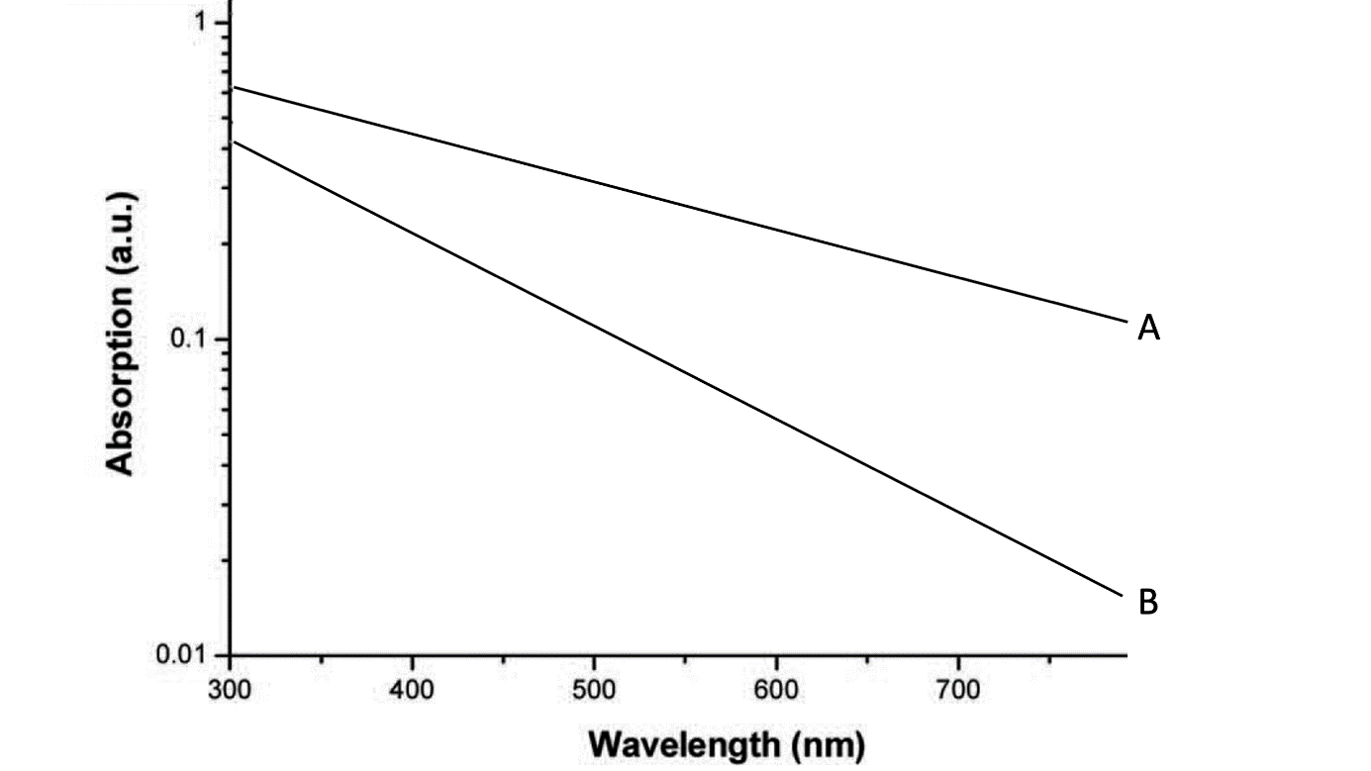
Fig. A3

Question A3.2 Decide which curve corresponds to eumelanins and which to pheomelanins. Write your answers in table in the Answer sheet. (0.5 points)
Question A3.3 Which options below explain your decision? Choose all statements that apply and indicate them by a tick (√) in the table in the Answer sheet (select 0–3 answers). (1.5 points)
- The overall amount of light that passes through eumelanins would be expected to be lower, therefore the curve will be lower on the graph.
- Based on their known function, one could expect eumelanins to absorb more in the UV part of the spectra, therefore the absorbtion in the right part of the graph will be higher.
- Based on the colour of pheomelanins, we could expect more light from the yellow to red part of the spectra to pass through, therefore the curve will be lower in the right part of the graph.
In the next part we will be interested in the production of melanin, melanosome maturation, and regulation of these processes. Below is a scheme (Fig. A4) of the Raper–Mason pathway depicting the steps of melanin synthesis in mice. Some enzymes necessary for the production of pheomelanins or eumelanins are indicated in red.

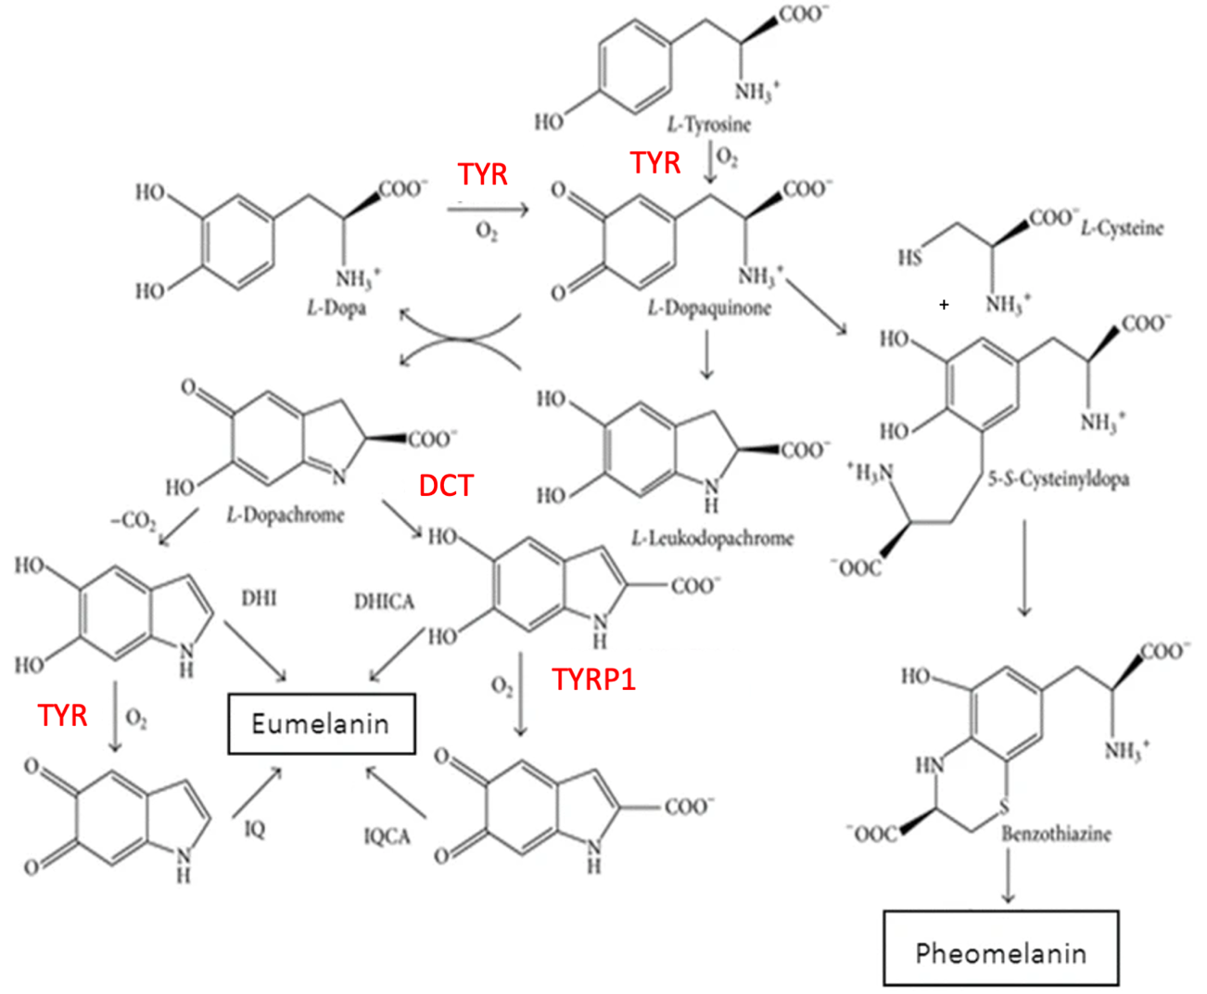
Fig. A4 Raper–Mason pathway of melanin synthesis.

In humans, this pathway as well as melanosome maturation is regulated based on UV light exposure of the skin. Below is a simplified scheme of this regulation. DNA damage in keratinocytes leads to activation of the protein p53 which activates expression of a peptide prohormone called proopiomelanocortin (POMC). POMC is further cleaved to different fragments such as adrenocorticotropic hormone (ACTH) which is then secreted by exocytosis. ACTH then binds to a protein receptor on melanocyte membrane, which leads to the activation of adenylyl cyclase via a signaling cascade. Adenylyl cyclase catalyses the production of cyclic adenosine monophosphate (cAMP) from ATP. cAMP binds to regulatory subunits of protein kinase A (PKA), causing them to dissociate, and thus activates the catalytic subunits of PKA. PKA then affects gene expression in two ways. First, it inhibits salt-inducible kinase (SIK) by phosphorylation. SIK, when active, phosphorylates one of CREB-regulated transcriptional coactivators (CRTC), preventing it from entering the nucleus. Unfosforylated CRTC migrates to the nucleus and forms a complex with CRE-binding protein (CREB). Second way by which PKA ensures expression of these genes is by direct activational phosphorylation of CREB. The complex of CRTC and phosphorylated CREB binds to specific DNA sequences, leading to expression of genes encoding enzymes of the Raper–Mason pathway, among others. These enzymes are tyrosinase (TYR), tyrosinase-related protein 1 (TYRP1), and dopachrome tautomerase (DCT).
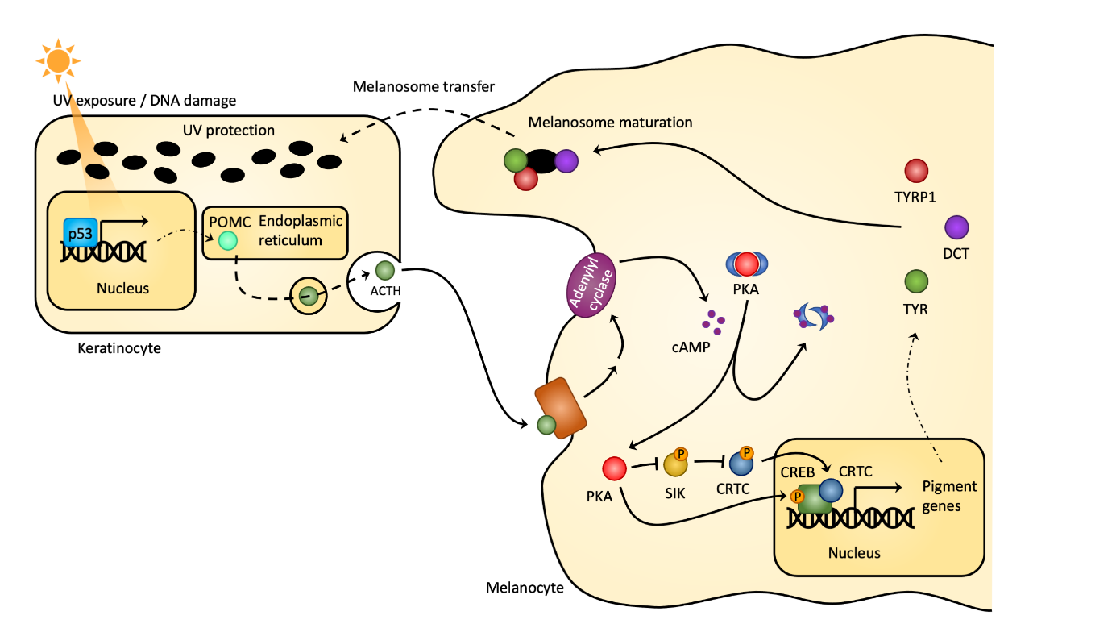
Fig. A5 Regulation of production of melanins.

Question A3.4 Decide whether the following statements are true based on information in the text and figures above. Choose all true statements and indicate them by a tick (√) in the table in the Answer sheet (select 0–10 answers). (5 points)
- POMC is likely translated on ribosomes bound to rough endoplasmic reticulum.

- Large-scale deletion in the gene encoding POMC in melanocytes would lead to hypopigmentation.

- A gain-of-function (=activating) mutation in the gene encoding adenylyl cyclase in melanocytes would likely lead to hypopigmentation due to less eumelanin being produced.

- A successful inhibition of SIK could lead to hyperpigmentation due to more melanins being produced.

- An inhibition of cAMP binding to regulatory subunits of PKA would lead to hyperpigmentation.

- A loss-of-function (=inhibiting) mutation in PKA in melanocytes would lead to hyperpigmentation.

- A mutation causing a substitution of the serine in CRTC that is phosphorylated by SIK for cysteine, which cannot be phosphorylated by SIK, would lead to hypopigmentation due to less eumelanin being produced.

- The cAMP producing step of the signaling cascade in melanocytes could lead to signal amplification.

- In case of a loss-of-function mutation in the gene encoding tyrosinase (TYR), eumelanin, but not pheomelanin would still be produced by melanocytes.

- PKA activates SIK by phosphorylation.

Paracrine regulation of melanogenesis is not the only function of ACTH. It is also produced into the blood (endocrine secretion) by a specific population of cells in the anterior pituitary (adenohypophysis), and its main function is positive regulation of glucocorticoid production in adrenal cortex. However, in high concentration it can have the same effect on melanocytes in skin as described above. Adenohypophyseal ACTH secretion is regulated by at least two mechanisms: 1) positively by corticotropin-releasing hormone (CRH) from the hypothalamus, and 2) negatively by glucocorticoids from adrenal cortex through a negative feedback loop which also controls the secretion of CRH (Fig. A6).

Fig. A6

Question A3.5 Decide in which cases would you expect hyperpigmentation based on the text and scheme above. Choose all true statements and indicate them by a tick (√) in the table in the Answer sheet (select 0–4 answers). (2 points)
- After destruction of adrenal cortex by an autoimmune reaction
- In case of a long-term medical administration of glucocorticoids
- In case of an adrenal cortex tumor with glucocorticoid-producing activity
- In case of a pituitary adenoma producing ACTH
Epidermal derivatives are also part of skin. They develop from epidermis, but are located within the dermis. These derivatives include hair, claws, and nails, amongst other things. Other important derivatives are skin glands, including sebaceous, aromatic, mammary, and sweat glands. In this section, we will turn our attention to the eccrine sweat gland. Pictured below is a scheme of the gland in the skin. It consists of a primary secretory part, sometimes called secretory coil, located in the dermis, and a secretory duct which leads the sweat to the epidermal surface but also reabsorps ions, resulting in the definitive sweat usually being hypotonic to interstitial fluid and blood plasma. The structure of both parts of the sweat gland is more complex, but for the purpose of this task assume both are formed by a single layer of epithelial cells.
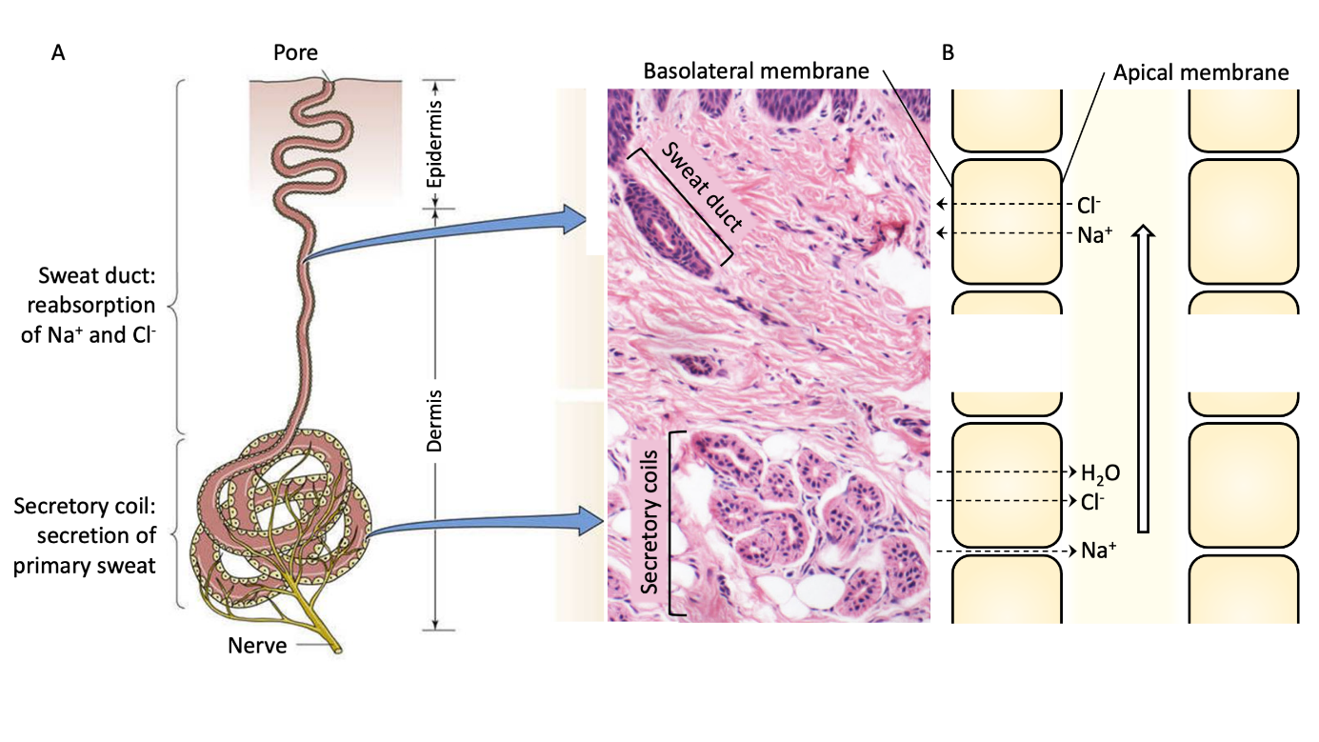
Fig. A7 Structure of eccrine sweat gland.

In the basolateral membrane of secretory coil cells, the protein Na⁺/K⁺ ATPase uses energy from ATP to transport Na⁺ ions from the cytosol to the extracellular fluid, producing a transmembrane gradient of this ion. Sweat production begins when nerve stimulation activates cotransport (symport) into the cell through the basolateral membrane of Cl⁻ ions with Na⁺ ions, utilising the mentioned gradient of Na⁺ as source of energy. Cl⁻ ions then leave the cell through channels in the apical membrane into the lumen of the secretory coil, followed by Na⁺ ions passing between the cells and water following the ionts osmotically through a different type of membrane channels called aquaporins. This leads to the production of isotonic primary sweat as compared to interstitial fluid or blood plasma (part B of Fig. A7).
Hypotonic sweat is then produced in the sweat duct by reabsorption of most Na⁺ and Cl⁻ ions (Fig. 8). Na⁺ enters the cells through the epithelial sodium channel (ENaC) on the apical membranes and exits into the surrounding tissue through the basolateral membrane, transported by the Na⁺/K⁺ ATPase. This creates the necessary electrochemical gradient for Na⁺ reabsorption from the primary sweat. The excess K⁺ transported by the Na⁺/K⁺ ATPase exits the cell through a K⁺ channel in the basolateral membrane. The negative Cl⁻ ions follow the positive Na⁺ ions from the lumen into the cells and exit into the surrounding tissue interstitium. Cl⁻ ions pass both the apical and basal membranes through a Cl⁻-specific channel called CFTR. However, water does not pass from the sweat duct throught plasmatic membranes of the lining cells because, unlike in the secretory coil, there are no aquaporins. The cells are connected by tight intercellular junctions, thus water cannot be reabsorbed neither through the cells nor around them, leading to the production of hypotonic sweat with relatively more water and less ions than the interstitial fluid or plasma membrane.
CFTR means Cystic Fibrosis Transmembrane conductance Regulator. As the name suggest, it is a mutation in the gene encoding this specific protein that causes cystic fibrosis. This channel is found in many other epithelia throughout the body, including the lining of airways and the pancreatic ducts, where the mutation causes the most severe symptoms of cystic fibrosis. In sweat glands, a malfunction of CFTR results in less Cl⁻ being reabsorbed from sweat. This causes lower reabsorption of Na⁺ as well because the negative charge of Cl⁻ cannot compensate its positive charge, meaning it is much harder to transport it across the membranes. Lower overall reabsorption of both Na⁺ and Cl⁻ means higher concentration of NaCl in the definitive sweat. It is this salty taste of skin that is often noticed first in children with cystic fibrosis, usually by their parents when kissing them.
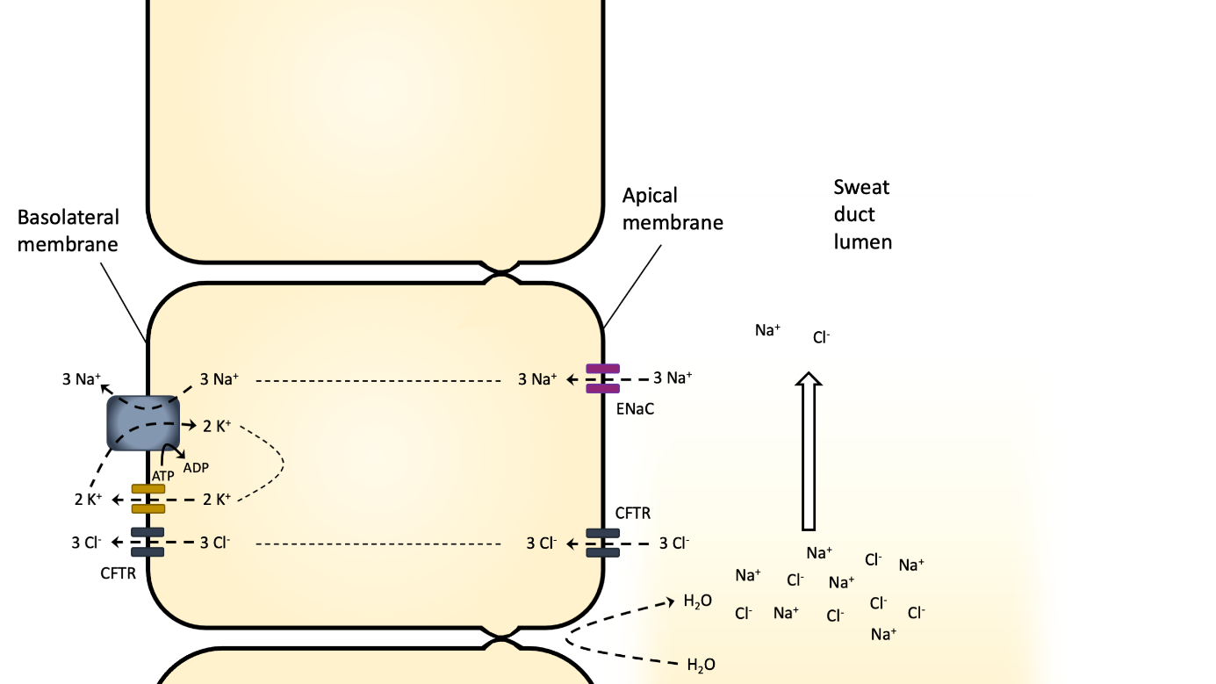
Fig. A8 Scheme of sweat duct ion reabsorption.

Question A3.6 Based on the information above, which of the following statements are true? Indicate them by a tick (√) in the table in the Answer sheet (select 0–9 answers). (4.5 points)
- Cl- ions flow across the apical membrane of the epithelial cells into the lumen of the secretory coil following their electrochemical gradient.

- Reduced function of the Na+/K+ ATPase in secretory coil cells would likely lead to hypertonic sweat production.

- Reduced function of the Na+/K+ ATPase in sweat duct cells would lead to hypertonic sweat production.

- In a healthy individual, it would be possible to encounter interstitial (blood plasma) Na+ concentration of 70 mmol/l and Na+ concentration in definitive sweat of 140 mmol/l

- In an individual with cystic fibrosis, Cl- concentration in definitive sweat can be expected to be up to twice as high as in the blood plasma/interstitial fluid.

- Transport of Na+, Cl-, and water into the lumen of the secretory coil is directly or indirectly dependent on ATP in the epithelial cells surrounding the lumen.

- Reabsorption of Na+ and Cl- from the primary sweat in the sweat duct is directly or indirectly dependent on ATP in the ductal epithelial cells.

- The concentration of Na+ ions in the interstitial fluid or blood plasma is higher than in the cytosol of the epithelial cells lining the secretory coil.

- The concentration of K+ ions in the interstitial fluid or blood plasma is lower than in the cytosol of the epithelial cells lining the sweat duct.

Question A3.7 When we are not sweating, the skin acts as a barrier preventing water loss. This function is ensured by the presence of hydrophobic contents of granules produced by cells in stratum granulosum and by sebaceous glands producing hydrophobic secretions onto the surface of the skin. However, naked mole-rats are adapted to living in relatively stable, warm, and very humid burrows their whole life. They completely lack both sweat glands and sebaceous glands, and the aforementioned granules of epidermal cells seem to contain much smaller amounts of hydrophobic products, especially in the skin on their abdomens. Which of the following statements make sense for the naked mole-rat in terms of thermoregulation and regulation of water loss? Indicate them by a tick (√) in the table in the Answer sheet (select 0–4 answers). (2 points)
- In above-surface conditions of relatively low humidity and mild temperature, the evaporative water loss through skin would be much higher in mouse than in the naked mole-rat
- The naked mole-rat developed an adaptation for situations of low humidity when it lies down on its back exposing its belly.
- In conditions of low temperature, naked mole-rats huddle together to reduce heat loss through conduction and evaporation
- During the day, naked mole-rats move to deeper parts of their burrows with higher humidity and lower temperature

Part B
Mechanical properties of hyaluronic acid
Hyaluronic acid has several interesting physical properties, for which it is used in medicine. It decreases friction, so it is injected into the osteoarthritic joints (e.g., in the knees), where it partially replaces the worn cartilages, and the joint can then move better. Due to its optical characteristics, hyaluronic acid is used during ophthalmic surgery. Another mechanical property, surface tension, is important for this application. One of the common uses of hyaluronic acid is also the filling of wrinkles in aesthetic medicine (as the so-called dermal filler). Hyaluronic acid binds water very strongly and can thus increase its volume.
In this task, you will study the above properties either on models or directly on hyaluronic acid. Hyaluronic acid chains can vary in length. A unit called dalton (Da) can be used for the length specification. Dalton is de facto a unit of molar mass and is numerically identical to g∙mol⁻¹.
List of equipment for Task B
- Small beaker
- Five samples of water-binding material in plastic bag
- Caliper
- Weight scales
- Petri dish
- 3D-printed inclined plane with rectangular block
- 500 kDa hyaluronic acid in the syringe
- Syringe for distilled water
- Stopwatch

IMPORTANT: You will use the same hyaluronic acid with molar mass 500 kDa as in the task C1! It is important to use it in Task C1 BEFORE tasks B2 and B3!

Task B1: Water binding properties (20 points total)
IMPORTANT: This task is designed for three and a half-hour. You will repeat the measurement according to the Table in the Answer Sheet, and you will have the last half hour to process the data. Therefore, you should start Task B1 now and solve Task B2 and Task B3 in the meantime.
In aqueous solutions, hyaluronic acid forms specific stable tertiary structures, which allows it to bond with large amounts of water. For simplicity, you will use a material model that binds water like hyaluronic acid, only faster in this task.
Physics describes reality by making models. One very commonly used model is an exponential one. When the hyaluronic acid binds water, it can first bind water a lot and, over time, less and less.
In the exponential models, we can introduce a quantity known as half-time. During this time, the amount of water that hyaluronic acid can absorb is halved. You can see this in Fig. B1.

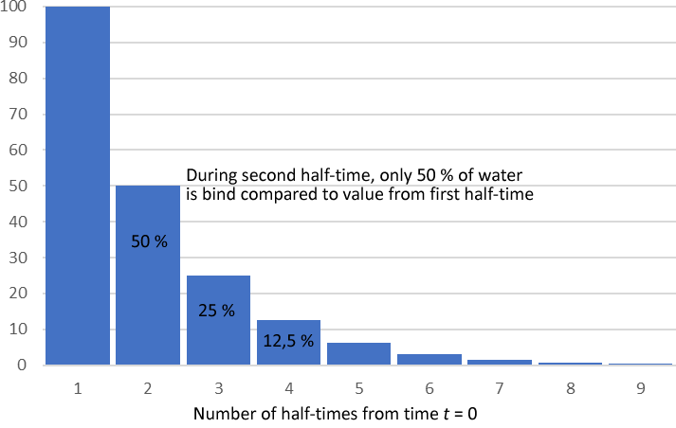
Fig. B1 Example of half-times.

Question B1.1 According to Fig. B1, draw Graph B1 to the Answer Sheet of total water bound by the hyaluronic acid as the function of time (let the first increase be 1.0 unit, the second 0.5 unit and so on). Express time in half-times like in Fig. 1, use data points, not bar chart. (4 points)
You will find material samples in the plastic bag. Measure its diameter with a caliper (you can measure just one sample). The mass of one sample in the dry state is 2.0±0.1 mg. Pour approximately 50 ml of distilled water into the beaker, throw in the samples, and write down the time. Then you will measure the diameter of the sample at the given times and use mass scales to determine its mass. You can use the timer. Fill in the results in the Table in the Answer Sheet.
IMPORTANT: Be careful when measuring the diameter because the sample is very fragile due to water content, and the sharp edge of the caliper can easily cut into it. Measure with the precision of tenths of a millimeter.
Question B1.2 Based on the measurements and data in Table B1, draw Graph B2 as the time dependence of the sample diameter and Graph B3 as the time dependence of weight. Use data points, not bar chart. (12 points)
Question B1.3 Conclude if the exponential models described the water binding in the sample correctly and estimate the half-time for the weight of the sample. (4 points)
TASK B2: Surface tension of hyaluronic acid (10 points)
Surface tension is the tendency of liquid surfaces at rest to shrink into the minimum surface area possible (e.g., to minimize so-called surface energy). For these reasons, the bubbles have the shape of a sphere. Hyaluronic acid is used in ophthalmology to treat glaucoma to adjust intraocular pressure. In this case, the surface tension of hyaluronic acid is essential. You can also consider that this quantity may not be correlated with the viscosity that is measured in Task C1. In this task, you will measure the surface tension on the hyaluronic acid using the stalagmometric (drop) method.
If a mass of liquid is stretched, the formation of drops occurs. If you imagine a dripping faucet (see Fig. B2), the water in the faucet is gaining mass until it is stretched to a point where the surface tension can no longer keep the drop to the faucet. The drop then separates, and surface tension forms the drop into a sphere.
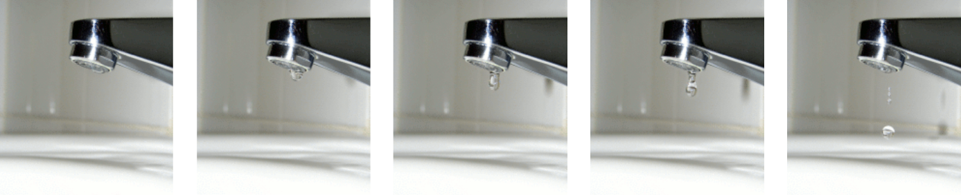
Fig. B2 Formation of drop on the dripping water faucet.
Surface tension $γ$as physical quantity is defined either as force per unit length, or as energy per unit area:
$$γ=\frac{F}{l}=\frac{E}{S},$$
so the unit is either $N∙m^{-1}$ or $J∙m^{-2}$. If you slowly push water from the syringe, you will see a drop forming at the outlet (needle adapter). A force of gravity acts on the drop downwards, but the surface forces keep the drop at the outlet of the syringe. When the force of gravity overcomes the surface forces, the drop separates from the syringe.
At that moment, this equation holds:
$$γ=\frac{mg}{πd},$$
where $m$ is the mass of the drop, $d=2.4 mm$ is the diameter of the outlet (needle adapter) and g = 9.8 m$∙$s⁻² is acceleration due to gravity. Because the mass of one drop is usually very small, it is reasonable to count e.g., 50 drops, measure the mass of these 50 drops, and calculate the mass $m$ of one drop.
Question B2.1a You will measure two samples: A solution of 500 kDa hyaluronic acid (Sample 1) and distilled water (Sample 2). (6.5 points)
The procedure:
- Place an empty Petri dish on the digital weight scales. If you turn on the scales after placing the Petri dish on it, the scales will take the dish weight into account and show 0.00 g. If you put the Petri dish on the scales after, you must press the “TARE” button to reset the scale.
- Slowly squeeze the drops of hyaluronic acid into a Petri dish and count them. Once you count 50 drops, write down the weight on the Answer Sheet.
- You will repeat this procedure five times for Sample 1 (500 kDa hyaluronic acid) and five times for Sample 2 (distilled water). After every measurement, draw Sample 1 back to the syringe – you have only 10 ml of Sample 1, and you will need it for Task B3 also!

Question B2.1b Determine the observation error as the arithmetic mean of the deviations of individual measurements. (2.5 points)
As the first step, you will write down the calculated values in the tables (Question B2.1.). Then you determine the absolute deviations of individual measurements $Δγ$ by calculating the absolute value of the difference between the calculated arithmetic mean $\overline{γ}$and the individual measurements:
$∆γ=\left| \overline{γ}- γ\right|$.

So for the first measurement, we calculate the absolute value of the arithmetic mean minus the first measured value. For the second measurement, we calculate the absolute value of the arithmetic mean minus the second measured value and so on.
The final value of the absolute error $∆\overline{γ}$ is the arithmetic mean of the individual absolute errors from the last column of the tables in Question B2.1. Round this deviation to one significant digit and round the arithmetic mean to the same number of decimal places as the absolute error. Write down the measured value in the form of $γ=(\overline{γ}±∆\overline{γ})$.
Question B2.2 (1 point)
Decide according to your measurement and circle the right answer in the Answer sheet:
a) The surface tension of hyaluronic acid solution is higher than water.
b) The surface tension of hyaluronic acid solution is lower than water.
c) We cannot decide if this is case a) or case b).

TASK B3: Lubrication properties of hyaluronic acid (20 points total)
As was mentioned before, hyaluronic acid binds well to water, producing a viscous fluid. This viscous fluid provides lubrication and acts as a shock absorber within the joint, reducing inflammation caused by wearing the cartilage and bone in osteoarthritic joints.
The physical quantity that describes two surfaces just before they start to move on each other is the static friction coefficient, which you will measure in this task. For the friction force, we have the Coulomb-Amonont law of dry friction:
$$F_{f}=fN,$$
where $f$ is the coefficient of static friction and $N$ is the normal force (force perpendicular to the surface). This friction force always acts in the opposite direction to that in which the block is pulled or pushed.
When an object rests on an incline that makes an angle $α$ with the horizontal plane, the force of gravity $F_{G}$ acting on the object is divided into two components: A normal component $F_{2}$ acting perpendicular to the plane and a component acting parallel to the plane, which we denote here $F_{1}$ (see Fig. B4).
$$F_{1}$$
$$F_{2}$$

$$F_{G}$$
$$α$$
$$α$$

Fig. B4 Inclined plane.

If we put the block on the inclined plane and gradually increase the angle $α$, at the beginning, the block will not move (because the static friction force $F_{f}$ is increasing as the component $F_{1}$ of the force is increasing). However, if we exceed the maximum angle $α_{max}$, the block begins to move down the inclined plane. For this angle, the following equation holds:
$$f=\tan{α_{max}}.$$

Question B3.1 (2 points)
Derive the equation $f=\tan{α_{max}}$and explain what happens in terms of the forces acting on the block (draw picture if necessary).

Now you will measure the coefficients of static friction with the apparatus in Fig. B5. You can adjust the angle $α$ of the inclined plane.
IMPORTANT: If the joint of the inclined plane comes loose, you can gently tighten it.
The block you have has two sides: one smooth and one rough. The inclined plane has only a smooth upper side. You will measure the coefficient of dry friction for these conditions:
- The dry, rough side of the block on the smooth side of the inclined plane.
- The dry, smooth side of the block on the smooth side of the inclined plane.
- The rough side of the block lubricated with hyaluronic acid solution on the smooth side of the inclined plane.
- The smooth side of the block lubricated with hyaluronic acid solution on the smooth side of the inclined plane.
For the measurement of coefficients of dry friction on lubricated surfaces use the syringe from the Task B2, dilute this sample 1 : 1 with distilled water using a beaker or Petri dish and draw back into the syringe. Then drip few drops of hyaluronic acid solution onto the the inclined plane, smear it and then put the block on.
IMPORTANT: It is crucial to set the angle as the first step, and then put the few drops on the top of the inclined plane and then put the block on it. When searching for the $α_{max}$, always put new drops on the top of the plane before each attempt!
Question B3.2 Fill the Table in the Answer Sheet for these conditions (6 points):
- The dry, rough side of the block on the smooth side of the inclined plane.
- The dry, smooth side of the block on the smooth side of the inclined plane.
Find the angle $α_{max}$ for which the block will start to move. In each case, adjust the angle five times and use the length of the inclined plane $l$ and height $h$ to calculate the angle $α_{max}$ and the corresponding coefficient of dry friction $f$.
Question B3.3 Calculate the coefficient of the static friction for conditions from Question B3.2, calculate the observational error using the same procedure as in Task B2. (2 points)
Question B3.4 Fill the Table in the Answer Sheet for these conditions (6 points):
- The rough side of the block lubricated with hyaluronic acid on the smooth side of the inclined plane.
- The smooth side of the block lubricated with hyaluronic acid on the smooth side of the inclined plane.
Find the angle $α_{max}$ for which the block will start to move. In each case, adjust the angle five times and use the length of the inclined plane $l$ and height $h$ to calculate the angle $α_{max}$ and the corresponding coefficient of dry friction $f$. Calculate the observational error using the same procedure as in Task B2
Question B3.5 Calculate the coefficient of the dry friction for conditions from Question B3.4, calculate the observational error using the same procedure as in Task B2. (2 points)
Question B3.6 Express as a percentage how much the coefficient of friction has decreased in 1., 3. and 2., 4. from Questions B3.3 and B3.5 if the parts have been lubricated with hyaluronic acid. (2 points)
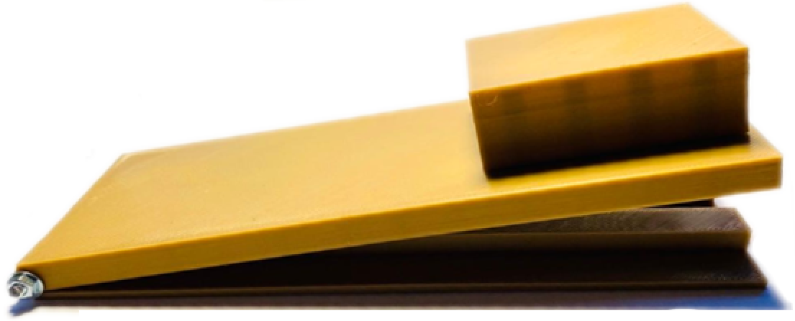
Fig. B5 Inclined plane apparatus.

Part C
Task C1: Viscosity of polymer solution (19 points)
IMPORTANT: You will use the same hyaluronic acid with molar mass 500 kDa as in the task B2 and B3! It is important to use it in Task C1 BEFORE tasks B2 and B3!

The falling ball and a lengthy polymer
The Czech Republic counts as the world’s producer of hyaluronic acid polymer and its medically applicable derivatives. Hyaluronic acid is polysaccharide consisting of molecules of d-glucuronic acid and N-acetyl-d-glucosamine connected by glycosidic bond, which form a repetitive structural unit of a polymer.

Fig. C1 Structural formula of glucose (left) and hyaluronic acid (right). Hydrogen atoms attached to carbons are omitted in hyaluronic acid for clarity.

Hyaluronic acid chains can vary in length. A unit called dalton (Da) can be used for the length specification. Dalton is de facto a unit of molar mass and is numerically identical to g∙mol⁻¹.
Another way to express the length of a chain can be stating the number of structural units in the chain (value of n from Fig. C1). This is called degree of polymerization and is dimensionless.
Question C1.1 How many carbon atoms are in a structural unit of hyaluronic acid? Calculate the degree of polymerization of hyaluronic acid chain weighting 150 kDa (kilodalton). Write down the results into the Answer sheet. Molar masses: M(H) = 1 g∙mol⁻¹, M(C) = 12 g∙mol⁻¹, M(N) = 14 g∙mol⁻¹, M(O) = 16 g∙mol⁻¹. (1.5 points)
List of chemicals for Task C1
- 10ml syringes with 2% hyaluronic acid solutions in water and metal ball:
  - one syringe: 500, 970, 1610 kDa hyaluronic acid
  - five syringes: 1900 kDa hyaluronic acid
- 2% solution of H₂O₂, 5 ml in a vial
- 0.02m solution of ZnSO₄, 5 ml in a vial
- 0.02m solution of Fe(NO₃)₃, 5 ml in a vial
List of equipment for Task C1
- 5 empty 20ml syringes
- 5 lock-lock syringe connectors
- holder for syringes (beakers or tumblers, 3 pieces)
- ruler
- marker
- 1 stopwatch
- 1 wall clock
- wash-bottle with distilled water

Viscosity of solution
The viscosity of solution, η, can be determined from speed of a ball falling (moving) through the solution using Stokes law. For laminar flow around a sphere it gives:
F_{r} = 6π ∙η ∙ r ∙ v
where F_{r} is the resistance force (Stokes drag), π is pi (Archimedes constant), r the radius of the ball and v is speed of the ball. In our experiment, the speed of the falling ball will be small and more-less constant. Therefore, speed of the ball can be simply calculated from length of the path and time of the fall. Due to a slow movement of the ball, it is reasonable to assume that all forces acting on the ball are balanced.
The relationship between the molecular weight of a dissolved polymer and the viscosity of a solution is described by semi-empirical Mark-Houwink equation:
[η ] = K ∙ M^{α}
where [η ] is the contribution of the dissolved polymer to viscosity of the whole solution (intrinsic viscosity), M is molar mass in suitable unit (usually in kDa, kilodaltones), and K and α are empirical constants. As the viscosity contribution of other species to the viscosity of the whole solution is negligible and as the concentration of the hyaluronic acid is identical in all syringes, we can assume that intrinsic viscosity of hyaluronic acid equals the viscosity of the whole solution.

Polymer degradation
Some bonds in long chain of polymer can be split under certain conditions. Such degradation can occur by different mechanisms. They are for example oxidative treatment (bond splitting by reaction with oxidation agent, e.g. O₂, H₂O₂, NaClO...), simple hydrolysis (reaction with water molecule), proton- or hydroxide-assisted hydrolysis (reaction with water molecule after preceding attack of H⁺ or OH⁻ ions present in acid/alkaline media), metal-assisted hydrolysis (coordination of the metal ion to the polymer backbone can influence ability of some bonds in the chain for water/hydroxide ion attack; e.g. Zn²⁺ is utilized by some peptidases – enzymes hydrolysing peptides), etc.
Procedure
Viscosity measurement
In front of you, there are 4 syringes filled with 2.0% wt. hyaluronic acid solution in water labelled with molar mass of used polymer (500 kDa – white tip, 970 kDa – blue tip, 1610 kDa – red tip and 1900 kDa – blue-white tip) containing a steel ball.
Question C1.2 If you flip the syringe over, the ball will fall. The time of fall is dependent on the viscosity of the solution, which is affected by the polymer chain length, as described above. Measure the time of fall of the steel ball in each syringe. You can repeat the measurement couple of times to obtain reproducible result. Write down the accepted times (t) into the Answer sheet. Measure the trajectory length of the balls (l) in individual syringes (should be approximately the same) and write down the values into the Worksheet. Calculate speed of the balls in individual solutions and write down the results into the Answer sheet. (1 point)
Question C1.3 Based on your results, calculate viscosity of individual solutions. Density of studied solutions is 1.0 g∙cm⁻³, density of steel ball is 7.5 g∙cm⁻³, diameter of the ball is 5.0 mm, gravitational acceleration is 9.8 m∙s⁻². Write down the viscosity values in N∙s∙mm⁻² into the Answer sheet and transfer the values to Pa∙s units. (6.5 points)
Question C1.4 Using graph paper, try to determine empirical constants K and α by interpolation of your data. Find a way to linearize the Mark-Houwink equation, so the data could be fitted by a straight line. Use values of viscosity in Pa∙s units. Choose suitable ruler of the graph. (3 points)

Polymer degradation
Polymeric hyaluronic acid can be split in smaller fragments. You will test several methods suggested for such degradation. The proposed conditions/solutions to be tested are:
a. Oxidative treatment with H₂O₂ (approx 1 ml of 2% H₂O₂ and approx 1 ml of water).
b. Metal-assisted hydrolysis using Fe(NO₃)₃ (approx 1 ml of 0.02m Fe(NO₃)₃ and approx 1 ml of water).
c. Metal-assisted hydrolysis using ZnSO₄ (approx 1 ml of 0.02m ZnSO₄ and approx 1 ml of water).
d. Combined treatment with H₂O₂ and Fe(NO₃)₃ (approx 1 ml of 2% H₂O₂ and approx 1 ml of 0.02m Fe(NO₃)₃).
e. Combined treatment with H₂O₂ and ZnSO₄ (approx 1 ml of 2% H₂O₂ and approx 1 ml of 0.02m ZnSO₄).
For the measurement use five syringes with the polymer of the highest molecular mass (1900 kDa) – the one used for the previous experiment and other for nonlabeled syringes with the blue-white tip. To assure comparability of results, each polymer solution should be diluted with the same volume of selected agent. The volume of the agent will be measured using empty syringe in which the individual solutions (a.– e. in Question C1.5) will be mixed, and the reagent will be mixed with the polymer solution using following procedure: connect the syringe with the reagent solution to the syringe with hyaluronic acid solution via lock-lock syringe connector. Mix the solutions by transporting the solutions from one syringe to the other for approx. 100 s. Start to measure the ball falling time with the stopwatches. If the ball does not move at all, it may get stuck to a wall of the syringe. Gentle pressing of the piston should help to start it. If this does not help, continue with mixing for ca 30 s, then repeat the measurement of falling time. Repeat the measurement each 3–5 min to obtain at least 5 data points for each mixed solution. Notice start of each of your experiments according to the wall clock. Do not disconnect the syringes.
Question C1.5 Measure effect of individual reagents (conditions a–e) as simultaneously as possible to obtain as much data in less total time.
Composition of reagent solutions is following:
a. Mix approx 1 ml of 2% H₂O₂ and approx 1 ml of water.
b. Mix approx 1 ml of 0.02m Fe(NO₃)₃ and approx 1 ml of water.
c. Mix approx 1 ml of 0.02m ZnSO₄ and approx 1 ml of water.
d. Mix approx 1 ml of 2% H₂O₂ and approx 1 ml of 0.02m Fe(NO₃)₃.
e. Mix approx 1 ml of 2% H₂O₂ and approx 1 ml of 0.02m ZnSO₄.
Write down times of ball fall in the Answer sheet. Notice starting time of your experiments. (5 points)
Question C1.6 Choose from the reagents a–e the most suitable one for cracking the hyaluronate chains. Is the reaction mechanism electrophilic, nucleophilic, or radical? Justify your statement. (2 points)
a) Electrophilic activation of the molecule of hydrogen peroxide before nucleophile attack of the sugar unit.
b) Catalytic role of the metal ion on peroxide decomposition – formation of HO∙ and HOO∙ radicals.
c) Electrophilic activation of the glycoside bond by coordination to the metal ion before nucleophilic attack of hydrogen peroxide.
d) Electrophilic activation of the glycoside bond by coordination to the metal ion before nucleophilic attack of water molecule.
e) Catalytic splitting of hydrogen peroxide to HO∙ radicals due to intermolecular hydrogen bonds formation with neighbouring hydroxide group after forming a cyclic intermediate.

Task C2 (16 points)
Volumetric determination of concentration and dissociation constant of d-glucuronic acid
Hyaluronic acid polymer is formed by a repeating disaccharide unit consisting of d-glucuronic acid and N-acetyl-d-glucosamine. Structural formula of d-glucuronic acid is shown on Fig. C2.

Fig. C2 Structural formula of d-glucuronic acid.

Concentration of glucuronic acid can be easily determined by acid-base titration. Moreover, a dissociation constant of the acid can be determined when using a suitable experimental setup.
List of chemicals for Task C2
- ca 0.01m NaOH
- ca 0.01m oxalic acid (exact concentration provided by lab assistants)
- sample solution of d-glucuronic acid
- phenolphthalein

List of equipment for Task C2
- 2 titration flask, 250ml
- burette, 25ml (+stand and holder)
- pipette, 10ml
- automatic pipette with tip, adjustable 1–5ml (can be common for few neighbouring groups)
- 2 vials with screw top, 20ml
- beaker, 250ml
- wash-bottle with distilled water
- pipetting balloon
- funnel
- pH-meter (for several groups)

Acid-base titration
During acid-base titration, an amount of the acid present in the sample is determined using titration with volumetric solution of the base (alkalimetry), or, vice versa, an amount of the base in the sample can be determined employing volumetric solution of the acid (acidimetry). In this Task, you will perform alkalimetric determination of concentration of organic acid with utilization of phenolphthalein as an acid-base indicator. As a volumetric (titration) agent, solution of sodium hydroxide, NaOH, will be used.
Acid-base indicator is generally a compound, which behave as acid or base (i.e. its molecule can be protonated or deprotonated during the titration), and differently protonated forms thereof have different colours. In the case of titration of organic acid (usually weak) with strong alkaline hydroxide, the equivalence point lies in weakly basic region. [In equivalence point, a molar amount of the acid protons is equal to a molar amount of the base hydroxide ions, i.e., formally, a solution of the salt is formed. However, the solution needs not to be neutral (pH can differ from 7), as concentrations of H₃O⁺ and OH⁻ ions need not be equal due to cation or anion hydrolysis.] Therefore, phenolphthalein is an appropriate indicator, as it shows colour change at pH ≈ 8.5–10. In the case of phenolphthalein, forms present in acid and basic solution have structures shown in Fig. C3:

Fig. C3 Forms of phenolphthalein molecule in dependence on solution pH.

Determination of exact concentration of the volumetric solution of NaOH
Some substances form stable and well-defined solid phase, and their concentration can be derived from exact weight of the compound and from the total volume of its solution. Such substances are called “primary standards”. Unfortunately, solid NaOH cannot be used as a primary standard, because it is hygroscopic, and its surface is contaminated by water/moisture and some carbonate. Exact concentration of the stock solution of NaOH thus cannot be defined on the basis of the weight. Therefore, it has to be determined using so called factorization titration. For the purpose, oxalic acid can be used, as its dihydrate is well-defined in the solid state, (CO₂H)₂∙2H₂O.
During factorization of NaOH, following neutralization reaction occurs:
(CO₂H)₂ + 2 NaOH (CO₂Na)₂ + 2 H₂O
When all oxalic acid is consumed, the first drop of NaOH titration solution steeply increase a value of pH and titrated mixture will change its colour from colourless to purple due to a phenolphthalein content.

Acid-base equilibria
Arrhenius (and Brønsted) acids in aqueous solution dissociate according to equation:
HA + H₂O H₃O⁺ + A⁻
(shortly also HA H⁺ + A⁻)
For the equilibrium, corresponding dissociation constant K_{A} can be defined:
$${\text{K}}_{\text{A}}\left(\text{HA}\right)\text{= }\frac{\left[{\text{H}}^{\text{+}}\right]\text{∙[}{\text{A}}^{–}\text{]}}{\text{[HA]}}$$
Values of dissociation constants can be of very different orders and, therefore, for practical reasons, they are presented in the form of negative common (decimal) logarithms, −logK_{A} = pK_{A}. If the acid is in the solution almost fully dissociated, i.e. equilibrium in the equation written above is significantly shifted to the products H⁺ and A⁻, it is obvious, that K_{A} >> 1, and value of pK_{A} is negative. The strongest acids are e.g. HClO₄ and HI, whose pK_{A} is ≈ −10. Contrary, acids, which are dissociated only in small extent – i.e. the equilibrium shown above is shifted towards non-dissociated reactant HA – have K_{A} << 1, and the value of their pK_{A} is positive. Because of a huge number of different acids, the scale of pK_{A} values is continuous. Acids with pK_{A} < 2 are called strong, acids with pK_{A} in the range 2–4 are medium-strong, in the range pK_{A} = 4–9 are weak, and with pK_{A} > 9 are very weak. The lower value of pK_{A} is, the stronger acid is and, thus, higher degree of dissociation in the solution is.
By logarithming of the definition of dissociation constant we get:
logK_{A}(HA) = log[H⁺] + log[A⁻] − log[HA]
and, thus:
$$\text{pH = }{\text{p}\text{K}}_{\text{A}}\text{ + log}\frac{\text{[}{\text{A}}^{–}\text{]}}{\text{[HA]}}$$
This equation is called Henderson-Hasselbalch equation. From the relationship, it is obvious that if concentrations of dissociated and non-dissociated forms are equal, their ratio equals to one, and the logarithmic term in the equation is equal to zero. In such a situation, pH = pK_{A}.
Organic acids are usually weak acids. In such case, the concentration of dissociated form A⁻ coming from direct dissociation of HA if negligible compared to concentration of non-dissociated form HA. When a base is gradually added into the solution of the acid HA, the species A⁻ is generated only in the amount corresponding to molar amount of the added base, according to equation:
HA + OH⁻ H₂O + A⁻
i.e. n(A⁻) = n(added OH⁻). Condition [HA] = [A⁻] is thus fulfilled in the case, when exactly one half of the total amount of base needed for neutralization is added into solution of the acid (i.e. one half of acid is neutralized to salt A⁻, and the second half of the acid remains in the form HA). For weak acids (attention, only! for weak acids), the following relationship is thus valid:
pK_{A} = pH at consumption of ½V(eq.)
Typical course of alkalimetric titration of weak acid is shown on Fig. C4 together with corresponding distribution diagram of non-dissociated acid and its anion. When a strong base is added into a solution of the weak acid, gradual neutralization occurs and pH of the solution is slowly increased. The concentration of A⁻ is increased adequately. This part of the titration curve is called “buffering region” – the dissolved material buffers (moderates) – i.e. with addition of the titration agent (in general acid or base) is pH of the mixture changed only slightly. Close to the equivalence point – i.e. point, where added molar amount of the base equals to starting molar amount of the acid – a slope of the titration curve is increased significantly. In region with a large excess of the base, the pH is changed again only slowly. It can be seen in the distribution diagram, that at pH = pK_{A} the concentrations of HA and A⁻ are equal.

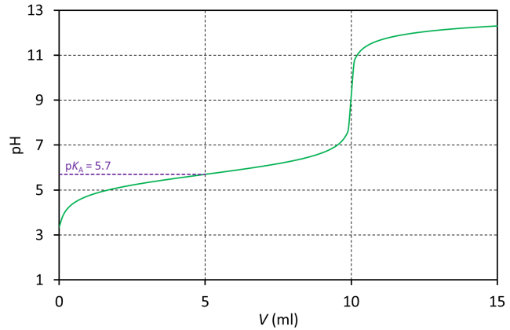 | 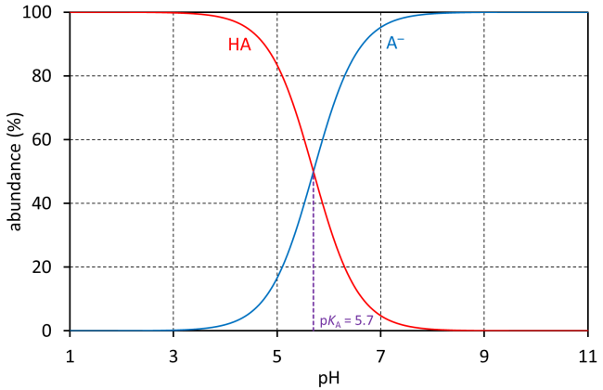
Fig. C4 Titration curve of titration of a weak monovalent acid HA with a strong base (left), and distribution of species HA and A⁻ in dependence on pH (right). Charts were simulated assuming pK_{A} = 5.7. For titration curve simulation, following conditions were defined: c(HA) = 0.1 m, V(HA) = 10 ml, titration solution was NaOH with c = 0.1 m. Equivalence point occurs at addition of 10 ml of titration agent.
Question C2.1 Value of pK_{A} of unsubstituted organic acids is ca 4.8 [e.g. pK_{A}(acetic acid) = 4.76, pK_{A}(propionic acid) = 4.88, pK_{A}(butyric acid) = 4.81].
Mark the reason, why pK_{A} of d-glucuronic acid differs from those of mentioned organic acids into the Answer sheet. (1 point)
a) Electron withdrawing inductive effect of electronegative oxygen atoms bound to the α-carbon.
b) Electron donating inductive effect of free electron pairs of oxygen atoms from hydroxo groups present in the molecule.
c) Carboxylate deprotonation is stabilized by an intramolecular hydrogen bonding due to a presence of neighbouring hydroxo group.
d) Better delocalization of the negative charge in the anion of d-glucuronic acid when compared to mentioned examples.
e) Due to positive mesomeric effect of the hydroxo group bound to the β-carbon.
f) Due to a general Pauling-Bell rule of correlation of acidity with number of oxo/hydroxo groups present in the molecule.

Question C2.2 In what pH region will solution of acetic acid work as the best buffer? Mark the right answer into the Answer sheet. (1 point)
a) pH 0–2 | b) pH 2–4 | c) pH 4–6 | d) pH 6–8 | e) pH 8–10

Question C2.3 In what pH region will lie pH of the 0.1m solution of sodium acetate? Mark the right answer into the Answer sheet. (1 point)
a) pH 2–4 | b) pH 4–6 | c) pH 6–8 | d) pH 8–10 | e) 10–12

Procedure
Factorization of NaOH stock solution
The stock solution of NaOH has an approximate concentration ca 0.01 mol∙dm⁻³. You have also stock solution of oxalic acid with known exact concentration (ca 0.01 mol∙dm⁻³ – exact concentration is given by lab assistants).
Fill the burette with the stock solution of NaOH. Use a small funnel; place a beaker under the burette. Remove the funnel after filling the burette and carefully lower a level of the stock solution in the burette to zero mark. Measure 10.0 ml of the oxalic acid stock solution using a pipette into a titration flask. Dilute the solution in the titration flask with ca 20 ml of distilled water and add
3–5 drops of indicator solution (phenolphthalein). Titrate the solution until first light purple colour, which will be stable for at least 5 s.
Question C2.4 Write down the exact concentration of the oxalic acid stock solution into the Answer sheet. Write down the volume of consumed titration agent. Repeat the titration. In the case that results of both titrations differ by more than 0.2 ml perform the third titration. Write down consumed volumes of all titrations into the Answer sheet. Into the Answer sheet, write down accepted value of consumed volume (averaged consumption from individual titrations, or the value obtained with exclusion of outlying result). (3 points)
Question C2.5 Based on the accepted value of the consumed volume, calculate exact concentration of the NaOH stock solution. (1 point)

Determination of concentration of d-glucuronic acid
Measure 2.50 ml of sample solution of d-glucuronic acid using an automatic pipette into the titration flask. Dilute the sample with ca 25 ml of distilled water and add 3–5 drops of phenolphthalein solution. Titrate the mixture with titration solution of NaOH according to procedure described above. Repeat the titration. In the case that results of both titrations differ by more than 0.2 ml perform the third titration.
Question C2.6 Write down consumed volumes of all titrations into the Answer sheet. Into the Answer sheet, write down accepted value of consumed volume. (3 points)
Question C2.7 Based on the accepted value of the consumed volume, calculate concentration of the sample solution of d-glucuronic acid. (1 point)

Determination of dissociation constant of d-glucuronic acid
Measure 2.50 ml of sample solution of d-glucuronic acid using an automatic pipette into two vials with screw top. Add appropriate volume of the NaOH stock solution using the burette (write the chosen volume into the Answer sheet). Choose the volume in such a way that pH of the final mixture will correspond to the value of pK_{A} of d-glucuronic acid. Close the vials and give them to a lab-assistant, who will measure pH of both solutions.
Question C2.8 Write down chosen volume of NaOH stock solution and measured pH values into the Answer sheet and determine pK_{A} value of d-glucuronic acid. (5 points)

Task C3 (15 points)
Spectrophotometric determination of concentration of N-acetyl-d-glucosamine
Hyaluronic acid polymer is formed by a repeating disaccharide unit consisting of d-glucuronic acid and N-acetyl-d-glucosamine. Structural formula of N-acetyl-d-glucosamine is shown on Fig. C5.

Fig. C5 Structural formula of N-acetyl-d-glucosamine.

Concentration of N-acetyl-d-glucosamine can be easily determined using spectrophotometry due to formation of a coloured products on reaction with 4-(N,N-dimethylamino)benzaldehyde (DMAB).

Spectrophotometry
Absorption spectroscopy in ultraviolet and visible region (UV-Vis region) studies an interaction of a matter with electromagnetic radiation in wavelength range ca 200–750 nm. The region can be divided to near ultraviolet part (200–400 nm, UV) and visible part of the spectra (400–750 nm, Vis). In the visible region, individual wavelengths correspond to different colours of the light (Fig. C6).

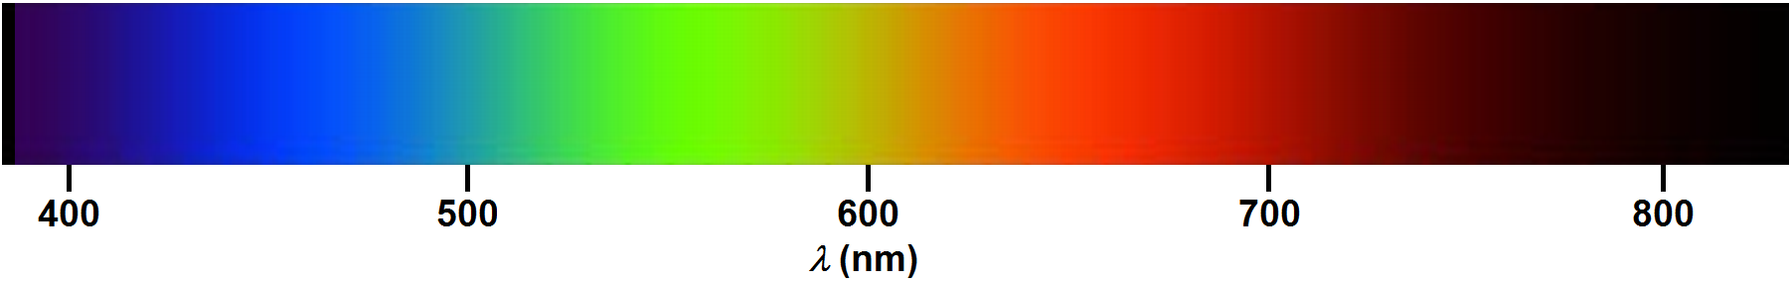
Fig. C6 Dependence of light colour on wavelength.

Absorption process in the UV-Vis region is associated with excitation of the molecule from the ground to the excited electronic state. UV-Vis absorption spectrum (dependence of absorption intensity on wavelength, frequency of the radiation or wavenumber) reflects an electronic structure of the molecule. If the compound absorbs photons from visible region, it is coloured, and it appears to our eyes in complementary colour to the colour of the absorbed light (Tab. C1).

λ (nm) | Colour
 | absorbed | complementary
400–435 | violet | yellow
435–480 | blue | orange
480–500 | blue-green | red-orange
500–560 | green | red
560–580 | yellow-green | red-violet
580–600 | yellow | violet
600–630 | orange | blue
630–750 | red | green
Tab. C1 Relationship between wavelength of the absorbed radiation and corresponding colour of the material.
Position of the absorption band is usually characterized by wavelength of maximum λ_{max} (in nm), by wavenumber ${\tilde{}}_{\text{max}}$ (in cm⁻¹), or as frequency ν_{max} (in Hz). Relations between these quantities and photon energy E_{photon} are following:
$$\tilde{ }\text{= }\frac{}{\text{c}}\text{= }{}^{\text{–1}}$$
and
$${\text{E}}_{\text{photon} }\text{=} \text{h}\text{∙} \text{=} \text{h}\text{∙}\text{c}\text{∙}\tilde{ }\text{= }\frac{\text{h}\text{∙}\text{c}}{}$$
where h is Planck constant (h = 6.626069∙10⁻³⁴ J∙s) and c is speed of light in vacuum (c = 299792458 m∙s⁻¹).
Question C3.1 What is energy of photon of light used with λ = 585 nm for spectrophotometric measurement? Write the value into the Answer sheet as frequency (in Hz) as well as wavenumber (in cm⁻¹). (2 points)
Change of intensity of light characterized by wavelength λ during passage through an absorbing material can be quantified by absorbance, A. Its relationship with concentration of the absorbing molecule in the sample and with length of the optical path (practically inner width of the cuvette) is expressed by Lambert-Beer law:
A(λ) = ε(λ) ∙ c ∙ l
where ε(λ) is molar absorption (extinction) coefficient at given wavelength λ. Extinction coefficient is for given compound and chosen wavelength constant and is presented usually in units dm³∙cm⁻¹∙mol⁻¹. The c is molar concentration of the absorbing compound in the sample (in mol∙dm⁻³) and l is optical path (in cm).
So, the Lambert-Beer law can be applied for quantification. Usually, at first, so-called calibration line is constructed, when values of absorbance are drawn versus known concentration of the solutions. Ideally, a line is obtained, which goes through origin of the Cartesian chart:
A = k ∙ c
Once absorbance of the sample with unknown concentration is measured, the concentration can be easily calculated from the equation of the calibration line or can be directly read from the graph.

List of chemicals for Task C3
- N-acetyl-d-glucosamine solution, c = 1.00∙10⁻³ mol∙dm⁻³, 1 ml
- Na₂B₄O₇ solution, c(Na₂B₄O₇) = 0.80 mol∙dm⁻³, 5 ml (pre-heated solution common for several groups)
- 4-(N,N-dimethylamino)benzaldehyde reagent, ca 10% solution in 1:9 mixture of conc. HCl:conc. AcOH, 20 ml
- sample of N-acetyl-d-glucosamine solution of unknown concentration, 0.5 ml

List of equipment for Task C3
- automatic pipette with tip, adjustable 1ml (can be common for few neighbouring groups)
- automatic pipette with tip, adjustable 1–5ml (can be common for few neighbouring groups)
- magnetic hot plate with oil bath
- stand + holder
- 6 wires (paper clips)
- 6 vials with screw top, 4ml
- marker
- 6 plastic cuvettes
- beaker, 100ml
- wash-bottle with distilled water
- Na₂B₄O₇ solution, c(Na₂B₄O₇) = 0.80 mol∙dm⁻³, placed on magnetic hot plate and pre-heated to 80 °C (for several groups)
- Spectrophotometer (for several groups)

Procedure
During the Task you will construct spectrophotometric calibration line using four solutions with known concentration and a blank solution. In addition, you will prepare also sample of unknown concentration for spectrophotometric measurement. As the coloured product of reaction between N-acetyl-d-glucosamine with 4-(N,N-dimethylamino)benzaldehyde is not stable in time and its colour is developing, it is necessary to prepare all solutions for spectrophotometry simultaneously and all solutions should be measured during a short time (ca 10 min). Measurements should be performed at 15–60 min after standard/sample preparation.

Preparation of solutions for spectrophotometric measurements and data treatment
Prepare solutions of N-acetyl-d-glucosamine of known concentrations by defined dilution of a stock solution with concentration of 1.00∙10⁻³ mol∙dm⁻³ according to Tab. C2. Use automatic pipette for measurement of required volumes, and mix the solutions in closable 4ml vials. Calculate concentrations of the standards 1–3 and write them into the Answer sheet.

standard | c(N-acetyl-d-glucosamine)  [mol∙dm⁻³] | V(N-acetyl-d-glucosamine)  [ml] | V(water)  [ml]
0 | 0 | 0 | 0.400
1 | ? | 0.100 | 0.300
2 | ? | 0.200 | 0.200
3 | ? | 0.300 | 0.100
4 | 1.00∙10⁻³ | 0.400 | 0
Tab. C2 Dilution of the stock solution of N-acetyl-d-glucosamine.
Measure 0.400 ml of solution of the sample with unknown concentration into other closable vial.
Measure 0.150 ml of sodium tetraborate of concentration c(Na₂B₄O₇) = 0.80 mol∙dm⁻³ pre-heated to 80 °C into the vials using automatic pipette. Close the vials and stir the content. Using a wire, hang the vials on a holder. Put the vials into an oil bath pre-heated to 95 °C by holder shift on a stand and let them heat for 10 min. After the period remove the vials from the bath and left them cool down to laboratory temperature. Open the vials and add 3.000 ml of DMAB agent solution (attention!, the agent is dissolved in mixture of concentrated acetic and hydrochloric acids) using automatic pipette. Close the vials, stir their content and left them for 15 min. After the period fill individual cuvettes for spectrophotometric measurements with the solutions and give them to the supervisors – they will measure absorbance of individual mixtures at 585 nm.
Question C3.2 Write absorbance values into the Answer sheet. (8 points)
Draw measured data points and construct a calibration line using a graph paper – choose suitable ruler. Absorbance of the standards were measured against pure water, therefore, absorbance of solution with zero concentration of N-acetyl-d-glucosamine (standard 0) can differ significantly from zero, as there are present also other absorbing species. Therefore, you can subtract the absorbance of standard 0 from absorbance of all other standards (and you will obtain the calibration line of formula A = k ∙ c). Alternatively, you can use uncorrected values. In such case you will obtain the calibration line with the constant term, i.e. in form A = k ∙ c + l. Both approaches are equivalent, it does not matter, which variant you will choose.
Question C3.3 Read the concentration of the unknown sample from the calibration line chart. (5 points)

