Marking scheme
Task A1 (20.5 points)
Question A1.1 Draw a representative section from slide A. Label with terms from Table 1. (8 points)
Technical requirements: 1 point maximum, 0 points minimum
magnification, drawn in pencil, large enough drawing. Each missing/incorrect −0.5 points
Drawing: 2.5 points maximum, 0 points minimum
Incorrect drawing of structure of epidermis (including structure of its layers) −0,5 points
Grossly incorrect structure of epidermis/dermis −1 point each
Any additional important inaccuracies −0,5 or −1 point each depending on severity (eg. missing hair follicles in mouse skin…)
Labels: 2.5 points maximum, 0 points minimum
Incorrectly labelled structures (from Table 1 or not) −0,5 points each
Superfluously labelled structures (from Table 1 or not) −0,5 points each
Unlabelled structures drawn −0,5 points each
Unlabelled dermis (H) or epidermis (I) −0,5 points each
Staining and preparation: 2 points maximum, 0 points minimum
Too weak or too strong staining hematoxylin/eosin −0,5 or −1 point each depending on severity
Additional imperfections or damage −0,5 or −1 point each depending on severity

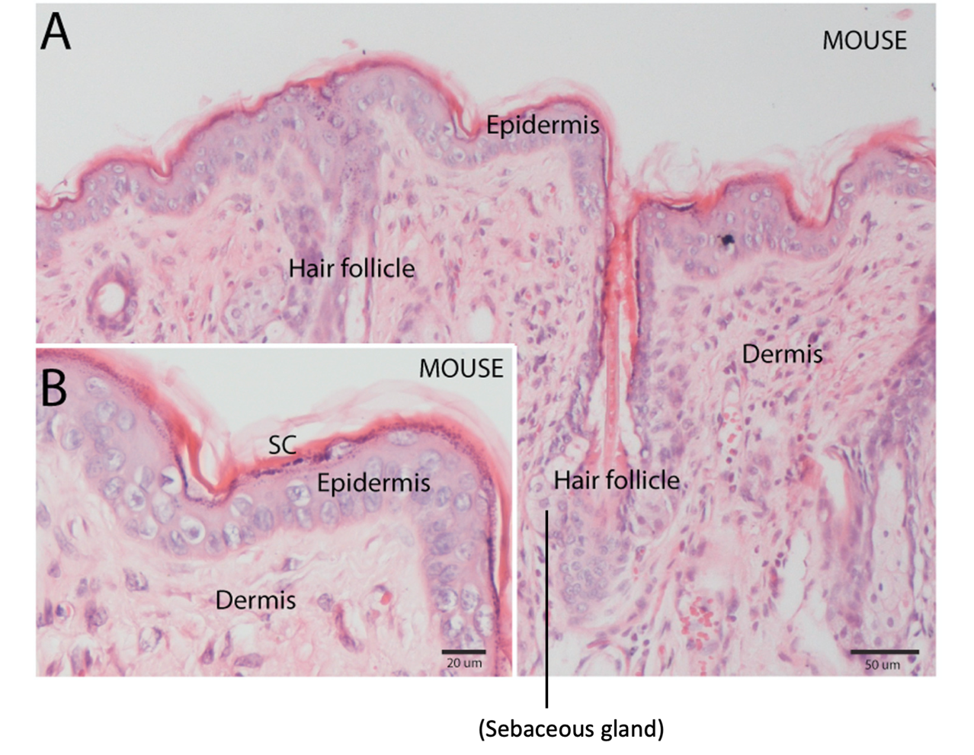

Question A1.2 Draw a representative section from slide B. Label with terms from Table 1. (8 points)
Technical requirements: 1 point maximum, 0 points minimum
magnification, drawn in pencil, large enough drawing. Each missing/incorrect −0.5 points
Drawing: 2.5 points maximum, 0 points minimum
Incorrect drawing of structure of epidermis (including structure of its layers) −0,5 points
Grossly incorrect structure of epidermis/dermis −1 point each
Any additional important inaccuracies −0,5 or −1 point each depending on severity (eg. inaccurate layer thickness ratios – thicker dermis in naked mole rat than in mouse)
Labels: 2.5 points maximum, 0 points minimum
Incorrectly labelled structures (from Table 1 or not) −0,5 points each
Superfluously labelled structures (from Table 1 or not) −0,5 points each
Unlabelled structures drawn −0,5 points each
Unlabelled dermis or epidermis −0,5 points each
Staining and preparation: 2 points maximum, 0 points minimum
Too weak or too strong staining hematoxylin/eosin −0,5 or −1 point each depending on severity
Additional imperfections or damage −0,5 or −1 point each depending on severity
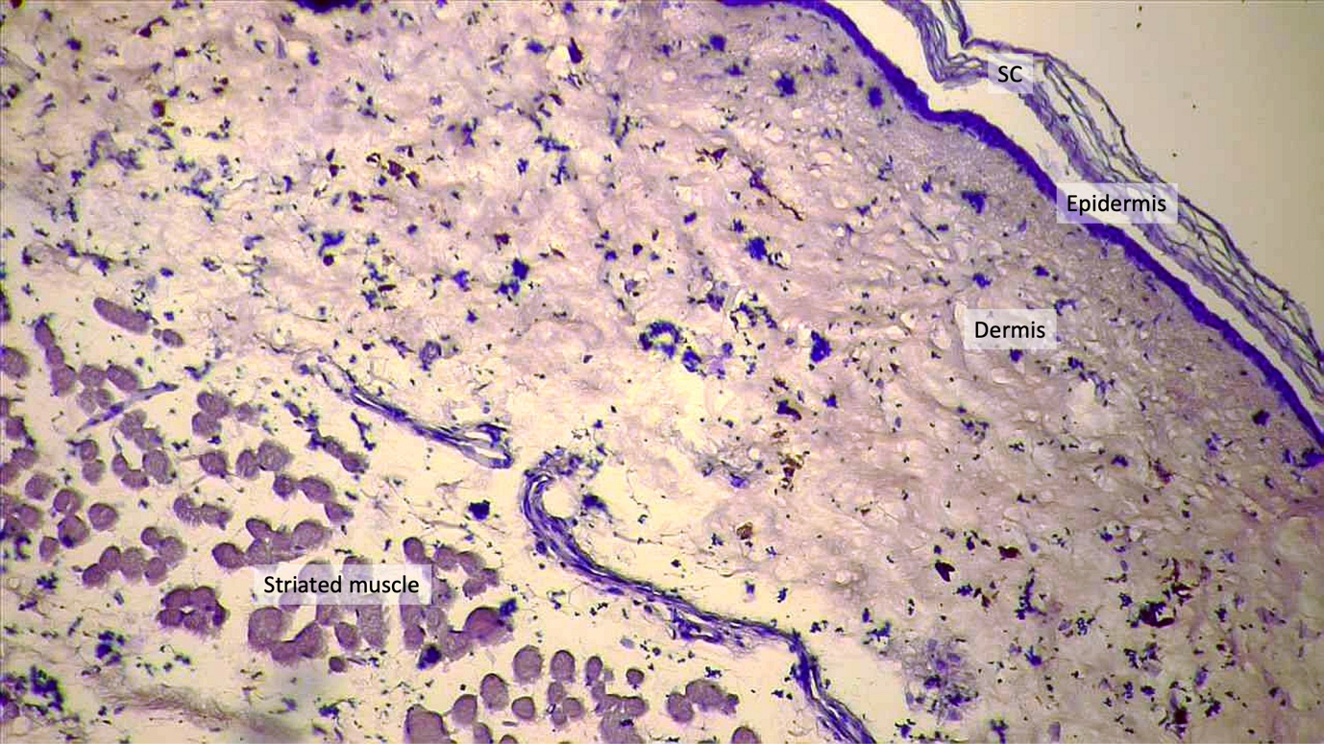

Question A1.3 Enter the letter (A or B) of your slides to the corresponding animal from which the skin sections were prepared. (1 point)
Mouse | A
Naked mole-rat | B
Any other solution 0 points

Question A1.4 Label the epidermal layers in one of your drawings from Question 1.1 or 1.2. (2 points)
Two layers flipped 1 point
Three or four layers misassigned 0 points
Any additional confusion in borders between layers or assignment of layers −0.5 points each
Incorrect drawing of epidermis including layers −0.5 points from question 1.1 or 1.2, do not deduct here

Question A1.5 Which biomolecule is most likely the target of hematoxylin staining? Indicate the corresponding molecule by a tick (√). (1.5 point)
cellulose
water
DNA | √
transmembrane proteins
phospholipids
simple sugars (oligosaccharides)
Any additional answer 0 points, no answer or any wrong answer 0 points

Task A2 (13 points)
Question A2.1 (8 points)
For each drawing (C1, C2, D1, D2) maximum 2 points
Technical requirements: magnification, drawn in pencil, large enough drawing. All correct 0.5 points, anything missing/incorrect 0 points
Drawing: maximum 0.5 points, gross inaccuracies 0 points
Any incorrect labelling −0.5 points each
Correctly indicated dermis in sections C2 and D1 as the stained layer 0.5 points each
Correctly labelled dermis in sections C2 and D1 as the stained layer 0.5 point each
In sections C1 and D2 no layer labelled as stained brown 1 point; any layer labelled as stained in any way 0 points

Question A2.2 Write the code of the section (C1, C2, D1, D2) to the corresponding field in the answer sheet. (2 points)
Animal origin | Treatment | Section code
Mouse | hyaluronidase | C1
Mouse | mock | C2
Naked mole-rat | hyaluronidase | D2
Naked mole-rat | mock | D1
Two options flipped 0.5 points
Three or four options misassigned 0 points

Question A2.3 Where do the extracellular matrix components come from? Choose the correct statement(s) regarding the protein and polysaccharides molecules found in the matrix and label with by a tick (√) in the answer sheet. (1 point)
They are directly extracted from the surrounding environment. The animal incorporates selected molecules into both superficial and deeper layers of skin.
They are largely synthetized by skin microbiome (mainly bacteria). Animals with different microbiome display different composition of extracellular matrix.
They are synthetized solely by liver cells. Blood and lymph transport them to the skin.
They are synthetized by cells directly in the tissue. Some molecules are made inside the cells and subsequently exported by exocytosis; others are synthetized by transmembrane enzymes. | √
Any other solution 0 points

Question A2.4 What is the role of HA in skin and other tissues? Pick the correct answer(s) by a tick (√) in the answer sheet. (2 point)
It maintains sufficient hydratation of the tissue. | √
It can serve as lubricant, e.g., in joints. | √
It has a large space-filling capacity. | √
It regulates migration of cells. | √
Each answer correctly ticked / not ticked 0.5 points

Task A3 (16.5 points)
Question A3.1 What type of molecular motors would you expect to be responsible for the transport of melanosomes to the cell periphery? (1 point)

Write the letter of the correct answer in the box

A
More than one letter in the box 0 points
Wrong answer, no answer 0 points

Question A3.2 Which absorbance curve corresponds to eumelanins and which to pheomelanins? (0.5 points)

Eumelanins | A
Pheomelanins | B
Any other solution 0 points

Question A3.3 Which statements are correct about eumelanin/pheomelanin absorption? Indicate by a tick (√) (select 0–3 answers). (1.5 points)

a)
b)
c) | √
Each answer correctly ticked / not ticked 0.5 points

Question A3.4 Which statements are correct about melanin production? Indicate by a tick (√) (select 0–10 answers). (5 points)

a) | √
b)
c)
d) | √
e)
f)
g)
h) | √
i)
j)
Each answer correctly ticked / not ticked 0.5 points

Question A3.5 In which cases would you expect hyperpigmentation? Choose all true statements and indicate them by a tick (√) (select 0–4 answers). (2 points)

a) | √
b)
c)
d) | √
Each answer correctly ticked / not ticked 0.5 points

Question A3.6 Which statements about regulation of sweat production are most likely true? Choose all true statements and indicate them by a tick (√) (select 0-9 answers). (4.5 points)

a) | √
b)
c)
d)
e)
f) | √
g) | √
h) | √
i) | √
Each answer correctly ticked / not ticked 0.5 points

Question A3.7 Which statements about thermoregulation and regulation of water loss in the naked mole rat make sense? Choose all true statements and indicate them by a tick (√) (select 0-4 answers). (2 points)

a)
b)
c) | √
d) | √
Each answer correctly ticked / not ticked 0.5 points

